**Start Your Title Here: Please Center, Use Times New Roman 12pt, Bold (In English)**

**First Author1, Second Author2, * and Third Author3 (12pt, centered)**

1affiliation of first author, including country (in English, 10pt. centered)

2affiliation of second author, including country (in English)

3affiliation in the same way (in English)

*Corresponding author

**Abstract.**

Here write the abstract 250-300 words in English! (Times New Roman 11 pt. alignment in block, spacing 1.5) Abstract should contain the Background, purpose, Methodology, Results and conclusion. text, text, text, text, text, text, text, text, text, text, text, text, text, text, text, text, text, text, text, text, text, text, text, text, text, text, text, text, text, text, text, text, text, text, text, text, text, text, text, text, text, text, text, text, text, text, text, text, text, text, text, text, text, text, text, text, text. text, text, text, text, text, text, text, text, text, text, text, text, text, text, text, text, text, text, text, text, text, text, text, text, text, text, text, text, text, text, text, text, text, text, text, text, text, text, text, text, text, text, text, text, text, text, text, text, text, text, text, text, text, text, text, text, text.

**Keywords:** key word, key word, key word (max 5 key words in English)

# **Introduction (TNR 1**4**pt., bold)**

The main text[1], (TNR 12pt., alignment in block, spacing 1,0) text, text, text, text, text, text, text, text, text, text, text, text, text, text, text, text, text, text, text, text, text, text, text, text, text, text, text, text, text, text, text, text, text, text, text, text, text, text, text, text, text, text, text, text, text, text, text, text, text, text, text, text, text.

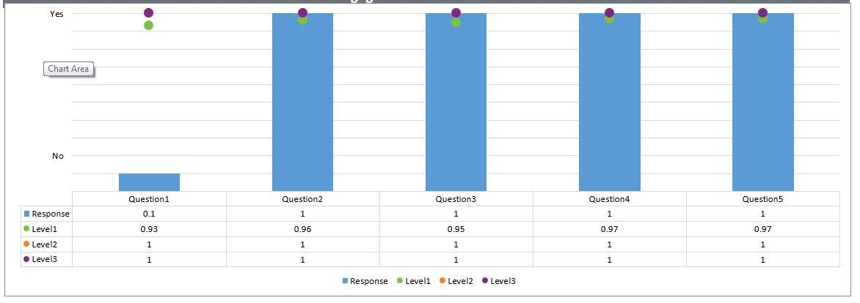

*Figure 1: Figure description (Times New Roman 10pt., centered, italics)*

*Source: (Times New Roman 10pt. italics)*

Text, text, text, text, text, text, text, text, text, text, text, text, text, text, text, text, text, text, text, text, text, text, text, text, text, text, text, text.

## **Title of the 2nd level (Times New Roman 12pt., bold)**

Text, text, text, text, text, text, text, text, text, text, text, text, text, text, text, text, text, text, text, text, text, text, text, text, text, text, text, text, text, text, text, text, text, text, text, text, text, text, text, text, text, text, text, text, text, text, text, text, text, text.

### **Title of the 3rd level (Times New Roman 12pt., bold)**

Text, text, text, text, text, text, text, text, text, text, text, text, text, text, text, text, text, text, text, text, text, text, text, text, text, text, text, text, text, text, text, text, text, text, text, text, text, text.

Tables and figures should be numbered and references to them must be in the text. Acceptable labeling for a table is Table.1 and Fig. 1 for a figure.

*Table 1: Table description (Times New Roman 10pt., italics)*

| Times New Roman 10pt | Times New Roman 10pt | Times New Roman 10pt |
| --- | --- | --- |
| Times New Roman 10pt | Times New Roman 10pt | Times New Roman 10pt |
| Times New Roman 10pt | Times New Roman 10pt | Times New Roman 10pt |
| Times New Roman 10pt | Times New Roman 10pt | Times New Roman 10pt |

### *Source:* *(TNR 10pt., italics)*

# **Body of paper (Times New Roman 14pt., bold)**

The article must be divided into chapters. *Introduction* and *conclusion* are obligatory. It is recommended to adjust body of the paper to the common organization structure of scientific papers –***Introduction,Problem Statement, Objectives, Materials and Methods, Significant of the study, Results and Discussion).***

# **Conclusion (Times New Roman 14pt., bold)**

### **Acknowledgment (Times New Roman 12pt. bold)**

This paper is an output of the science project…

**References (Times New Roman 12pt. bold)**

References in text citation should have this form (surname, year), for example:

1 author: (David, 1998)

1 author and the same year of publication: (Goethe, 2010, A.), (Raam, 2017,B )

2 authors: (David & Goethe, 2013)

3 authors: (Goethe et al., 2011)

### **References (Times New Roman 14pt., bold)**

Each work listed in the references must be cited in the text. All in-text citations and references must adhere to APA style (7th edition). For more information, visit [APA Style](http://www.apastyle.org/)

**(Book style -** Author, year. *Title (in italics).* Publisher, location of publisher.**)**

Cichocki, A. and Unbehaven, R., (1993). *Neural Networks for Optimization and Signal Processing*, 1st ed. Chichester, U.K.: Wiley.

Chen, W. K. (1993). *Linear Networks and Systems*, Belmont, CA: Wadsworth, pp. 123-135.

**(Journal -** Author, year. Paper title. *Journal name (in italics)*, volume and issue numbers, inclusive pages.**)**

Chen, S., Mulgrew, B. and Granta, P. M. (1993). “A clustering technique for digital communications channel equalization using radial basis function networks,” *IEEE Trans. on Neural Networks*, vol. 4, pp. 570-578.

Hill, R. M. (1997). The single-vendor single-buyer integrated production–inventory model with a generalized policy, *European Journal of Operational Research*, vol. 97, pp. 493-499.

**(Online Sources style)**

Vidmar, R. J. (August 1992). On the use of atmospheric plasmas as electromagnetic reflectors. IEEE Trans. Plasma Sci. [Online]. 21(3). pp. 876-880. Available: <http://www.halcyon.com/pub/journals/21ps03-vidmar>

**(Conference paper or contributed volume -** Author, year, paper title. *Proceedings title (in italics)*. City, country, inclusive pages.**)**

Beck, K. and Ralph, J. (1994). Patterns Generates Architectures.  *Proceedings of European Conference of Object-Oriented Programming.* Bologna, Italy, pp. 139-149.

***PLEASE RENAME DOCUMENT ACCORDING TO SURNAMES OF ALL AUTHORS AND PAPER NUMBER.***

***For example: kalindu_Nirnjala_Uvindu_Paper-ISAUS 2025***

1.